WordCount reading in system.txt and executing prior to modification:

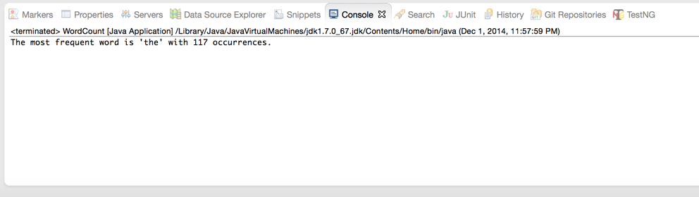

I attempted two modifications to the code per your instructions but both resulted in Null Pointer exceptions which I ran out of time debugging.

The two attempts were included as “_attempt1” and “_attempt2” respectively.